PhishGuard
HACK-O-WEEK | WEEK 3-4
HTML5 and CSS3

Section 1: Title
Hack-O-Week • Week 3-4 • HTML5 and CSS3. This report connects the college assignment to the inspected PhishGuard source code.

Section 2: Objective
Understand how semantic markup, accessible forms, and responsive CSS make a phishing URL checker clear and usable on different devices.

Section 3: Theory
HTML5 semantics. Elements such as main, section, article, nav, and footer describe the role of page content. Headings and landmarks make the interface easier to navigate.
Forms and accessibility. A form groups controls and submits on Enter or button activation. A programmatically associated label, keyboard focus indicator, descriptive error, and live status help assistive-technology and keyboard users.
Flexbox and Grid. Flexbox arranges items along one axis, such as the URL field and action buttons. Grid lays out two-dimensional panels, including the analysis result and its details.
Responsive design. Media queries change layout at narrower widths. Controls can wrap, navigation can scroll, and result columns can become a single column.
CSS variables. Custom properties store reusable colors and fonts. A shared token keeps surfaces, text, and risk colors consistent.

Section 4: Implementation in PhishGuard
The React interface mounts in the #root element from index.html. App.jsx supplies the main page, and URLScanner.jsx uses a semantic section and a labeled form. ScanHistory.jsx uses a table with column headings and a screen-reader-only label. index.css defines the dark color tokens, Flexbox URL entry, Grid result panels, visible keyboard focus, reduced-motion support, and breakpoints at 900, 760, and 540 pixels. Tailwind is imported, but most visible styling is regular CSS.

Section 5: Code Explanation
URLScanner form
Source: frontend/src/components/URLScanner.jsx
Actual implementation. The label is connected to the input, the submit event is handled by the form, and error/help text is referenced for assistive technology. The corresponding code is in this week’s companion Code_Examples.md file.
URL entry and result layout
Source: frontend/src/index.css
Actual CSS. Flexbox aligns the input controls, while Grid gives the diagnostic and detail panels separate columns on wide screens and one column on compact screens. The corresponding code is in this week’s companion Code_Examples.md file.
CSS tokens and focus treatment
Source: frontend/src/index.css
Actual CSS. Variables centralize repeated theme values, and :focus-visible makes keyboard focus visible. The stylesheet also includes screen-reader-only text, table scopes, and reduced-motion handling. The corresponding code is in this week’s companion Code_Examples.md file.

Section 6: Working Flow
- The user reaches the scanner inside the page main landmark.
- The label identifies the URL field and the form handles submit or Enter.
- CSS aligns the controls and styles validation feedback.
- At smaller widths, media queries wrap controls and collapse result columns.

Section 7: Learning Outcome
Semantic elements expose page structure, accessible form relationships guide input, and CSS layout rules keep the analysis readable from desktop to phone.

Section 8: Code Implementation Screenshots
Captured from the project source file open in Visual Studio Code. Captions identify the displayed file. Code examples are in the companion Code_Examples.md file, not in this Word report. Educational examples there are labeled and are not application code.
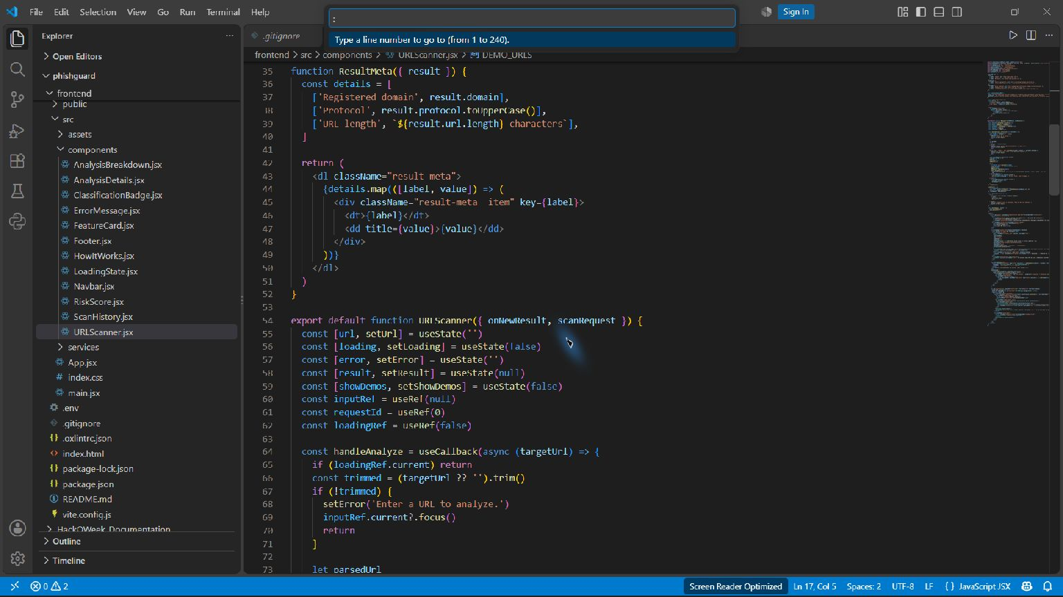
URLScanner form and accessible input — frontend/src/components/URLScanner.jsx
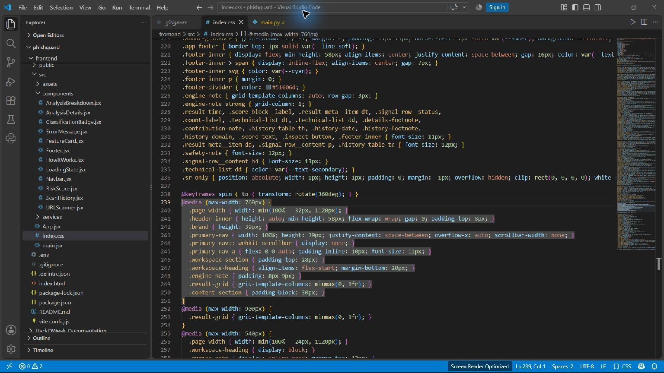
Flexbox, Grid, and responsive breakpoints — frontend/src/index.css

